Software Testing Report

Victoria Accident Data Visualisation Project

Max Woollons s5349356

Reiss Tooze s5046939

Kail Terepai s5307474

**Table of Contents**

1.0 Unit Tests 3

2.0 Coverage Report 4

3.0 Requirements Acceptance Testing 5

# Unit Tests

| **No** | **Test Case** | **Expected Results** | **Actual Results** |
| --- | --- | --- | --- |
| 1.0 | Date range is linear:  date_function(2013,2016) | Return '<' | Passed |
| 1.1 | Date range is not linear  date_function(2015,2014) | Return error ‘ERR’ | Passed |
| 1.2 | Date range is equal  date_function(2014,2014) | Return ‘==’ | Passed |
| 1.3 | Date range is linear:  date_function(2014,2018) | Return '<' | Passed |
| 1.4 | Date range is linear:  date_function(2014,2015) | Return '<' | Passed |
| 1.5 | Date range is not linear  date_function(2019,2015) | Return ‘ERR’ | Passed |
| 1.6 | Date range is not linear  date_function(2014,2013) | Return ‘ERR’ | Passed |
| 1.7 | Date range is equal  date_function(2019,2019) | Return ‘ERR’ | Passed |
| 1.8 | Date range is equal  date_function(2018,2018) | Return ‘==’ | Passed |
| 1.9 | Date range is linear  date_function(2015,2016) | Return '<' | Passed |
| 2.0 | Check if searched rows of data in dataframe contain a keyword.  keyword_function("Pedestrian") | Return True | Passed |
| 2.1 | Check if searched rows of data in dataframe contain a keyword.  keyword_function("Collision") | Return True | Passed |
| 2.2 | Check if searched rows of data in dataframe contain a keyword.  keyword_function("Struck Pedestrian") | Return True | Passed |
| 2.3 | Check if searched rows of data in dataframe contain a keyword.  keyword_function("Collision with vehicle") | Return True | Passed |
| 2.4 | Check if searched rows of data in dataframe contain a keyword.  keyword_function("Banana") | Return False | Passed |
| 2.5 | Check if searched rows of data in dataframe contain a keyword.  keyword_function("America") | Return False | Passed |
| 2.6 | Check if searched rows of data in dataframe contain a keyword.  keyword_function("Boat") | Return False | Passed |
| 2.7 | Check if searched rows of data in dataframe contain a keyword.  keyword_function("") | Return True | Passed |

# Coverage Report

Initially when running coverage, our coverage report was only showing 31%. A modified verion of main.py, called coveragetest.py was used to test the actual coverage of the code. The modified version added extra lines at the end of the main program to activate each of the functions used. Coveragetest.py was able to achieve a 100% coverage report with 11 lines of code excluded.

The lines of code were relating to errors which show as tkinter message boxes and some of the shortcuts entered for use in graph 3. The errors work as needed when the main program is run however we could not run coverage and execute certain message boxes as doing so caused the coverage test to crash. These functions do work in the pain program.

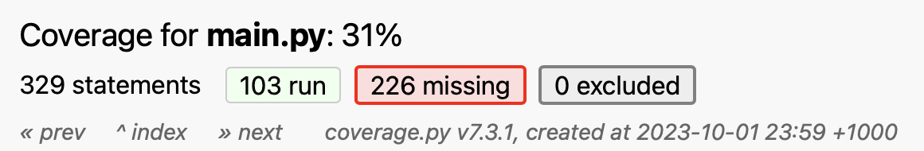

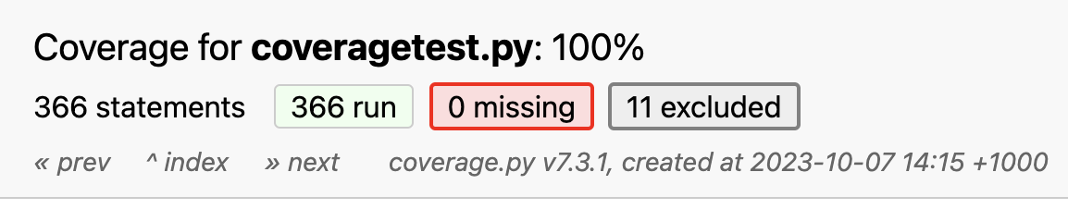

# Requirements Acceptance Testing

| **Software  Requirement No** | **Test** | **Implemented (Full /Partial/ None)** | **Test Results (Pass/ Fail)** | **Comments (for partial implementation or failed test results)** |
| --- | --- | --- | --- | --- |
| 1 | Specify a time period in the software and be shown data relating to the specified time period. | Full | Pass |  |
| 2 | Specify a time period in the software and be shown the average amount of accidents across a day at hourly intervals. | Full | Pass |  |
| 3 | Enter keywords relating to the accident and for the software to search and show data relating to the entered keyword(s). | Full | Pass |  |
| 4 | Clearly see the impact that alcohol has in Victorian accidents through visualisation. | Full | Pass |  |
| 5 | Select a year and view relevant data relating to accidents on public holidays. | None | N/A | Not included in final program. Not required by assignment |
| 6 | The program shall accept a csv document for data interpretation. | Full | Pass |  |
| 7 | The program shall filter data from the CSV document including   * Date ranges * Times of day * Keywords * Alcohol involvement * Accidents involving public holidays | Full | Pass |  |
| 8 | The program shall create charts based on data.   * These charts are based on mostly filtered data and include but are not limited to bar charts, pie charts, and plots which are to be shown in a GUI. | Full | Pass |  |
| 9 | The program shall allow the exporting of generated charts and other visualisations.   * These exported files will be images. | None | N/A | Not included in final program. Not required by assignment |